MELVILLE SENIOR HIGH SCHOOL
Year 11 Mathematics Specialist

Test 3 Semester 1, 2021
Topic 1.3 Vectors and Circle Geometry

Weighting - 7%




NAME: _______SOLUTIONS___________________ DATE_______________

Time allowed for this calculator-free section
Calculator-Free /25
Calculator-Assumed
/25

Test Total /50

= %
Reading time before commencing work: one minute
Working time for this section: twenty-five minutes

Time allowed for this calculator-assumed section
Reading time before commencing work: one minute
Working time for this section: twenty-six minutes

Materials required/recommended for Section One

To be provided by the supervisor
The Question/Answer Booklet
Formula Sheet

To be provided by the candidate
Standard items: pens, pencils, pencil sharpener, eraser, correction fluid/tape, ruler, highlighters

Special items: nil

Materials required/recommended for Section Two

To be provided by the supervisor
The Question/Answer booklet
Formula sheet (retained from Section One)

To be provided by the candidate
Standard items: pens (blue/black preferred), pencils (including coloured), sharpener,
correction fluid/tape, eraser, ruler, highlighters

Special items: drawing instruments, templates, notes on one unfolded sheet of A4 paper, and up to three calculators approved for use in this assessment.

Important note to candidates

No other items may be used in this assessment. It is your responsibility to ensure that you do not have any unauthorised notes or other items of a non-personal nature in the assessment room. If you have any unauthorised material with you, hand it to the supervisor before reading any further.

Structure of this assessment

Section | Number of questions available | Number of questions to be answered | Working time (minutes) | Marks available | Percentage of Assessment
Section One:  Calculator-free | 5 | 5 | 25 | 25 | 50%
Section Two:  Calculator -assumed | 4 | 4 | 25 | 25 | 50%
 |  |  | Totals | 50 | 100%

Instructions to candidates

1. The rules for the conduct of Western Australian examinations/assessment are detailed in the current Year 11 Information Handbook. Sitting this assessment implies that you agree to abide by these rules.

2. Write your answers in the spaces provided in this Question/Answer Booklet.
Spare pages are included at the end of this booklet.
They can be used for planning your responses and/or as additional space if required to continue an answer.
- Planning: If you use the spare pages for planning, indicate this clearly at the top of the page.
- Continuing an answer: If you need to use the space to continue an answer, indicate in the original answer space where the answer is continued, i.e. give the page number. Fill in the number of the question(s) that you are continuing to answer at the top of the page.

3. Show all your working clearly. Your working should be in sufficient detail to allow your answers to be checked readily and for marks to be awarded for reasoning. Incorrect answers given without supporting reasoning cannot be allocated any marks. For any question or part question worth more than two marks, valid working or justification is required to receive full marks. If you repeat an answer to any question, ensure that you cancel the answer you do not wish to have marked.

4. It is recommended that you do not use pencil, except in diagrams.

Section One: Calculator-free 50% (25 Marks)
This section has five (5) questions. Answer all questions. Write your answers in the spaces provided.

Working time for this section is 25 minutes.

Question 1 4 marks
The diagram below shows an isosceles triangle $BED$, its circumcircle and tangent at one vertex $B$.
∠ABD = $x$and ∠CBE = $y.$
Prove that





$$∠ABD=∠BED=x \left(alt segment\right)$$
$$∆EDB is an isosceles ∆ \left(EB=ED\right)$$
$$∠DBE=∠EDB=\frac{180-∠BED}{2}=\frac{180-x}{2}=90-\frac{x}{2}$$
$$x+90-\frac{x}{2}+y=180° (straight line)$$
$$\frac{x}{2}+y=90°$$
$$y=90°-\frac{x}{2}$$

***Various Answers – mark accordingly***

Question 2 6 marks
Determine the value for the variables in each of the following diagram



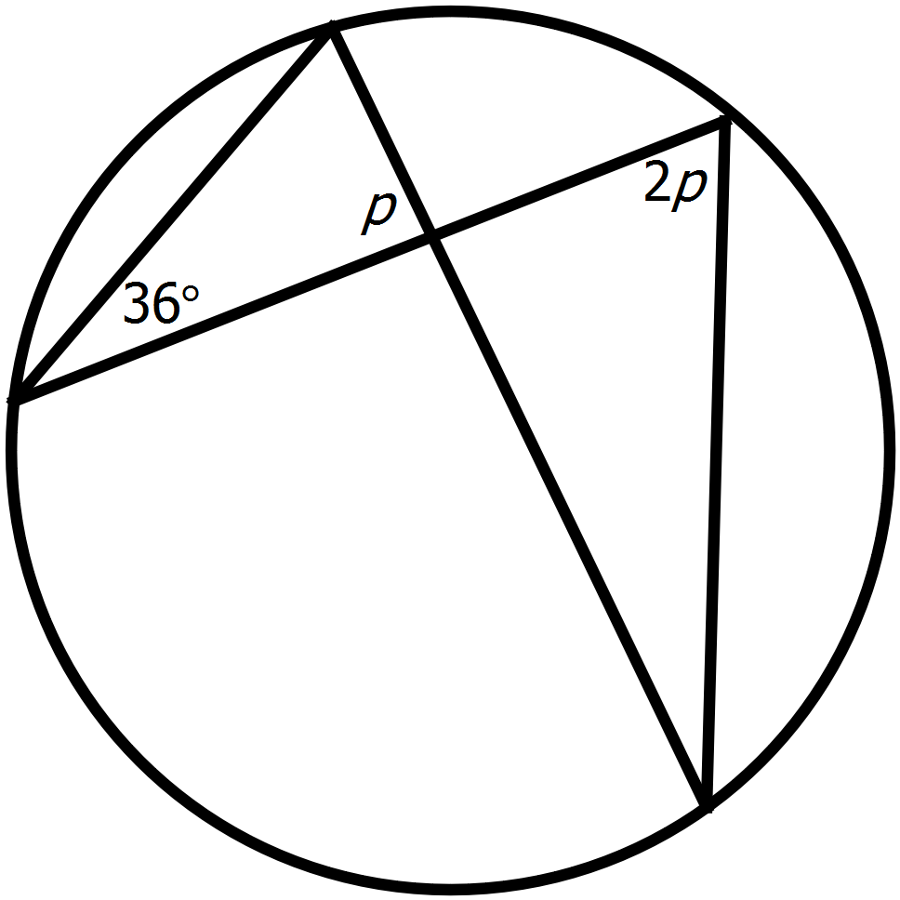
$$p+2p+36=180$$
$$3p=144$$
$$p=48$$


$$b=180-65=115°$$
$$a=29° \left(alt seg\right)$$
$$m=180-115-29=36°$$

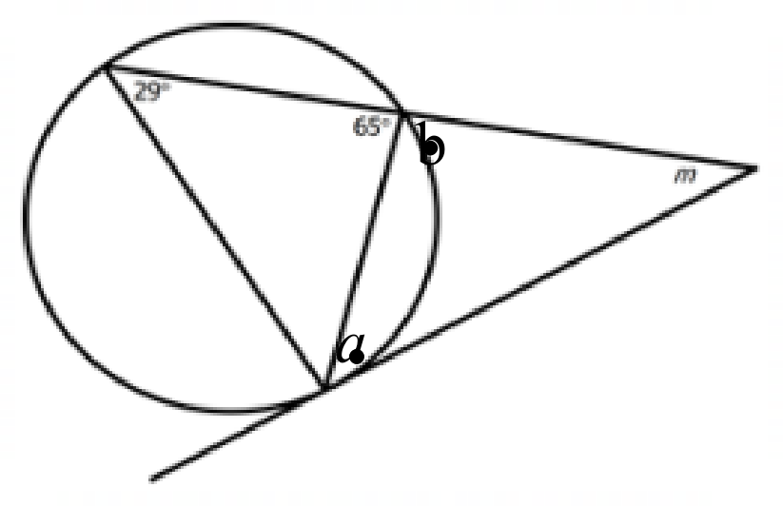



- 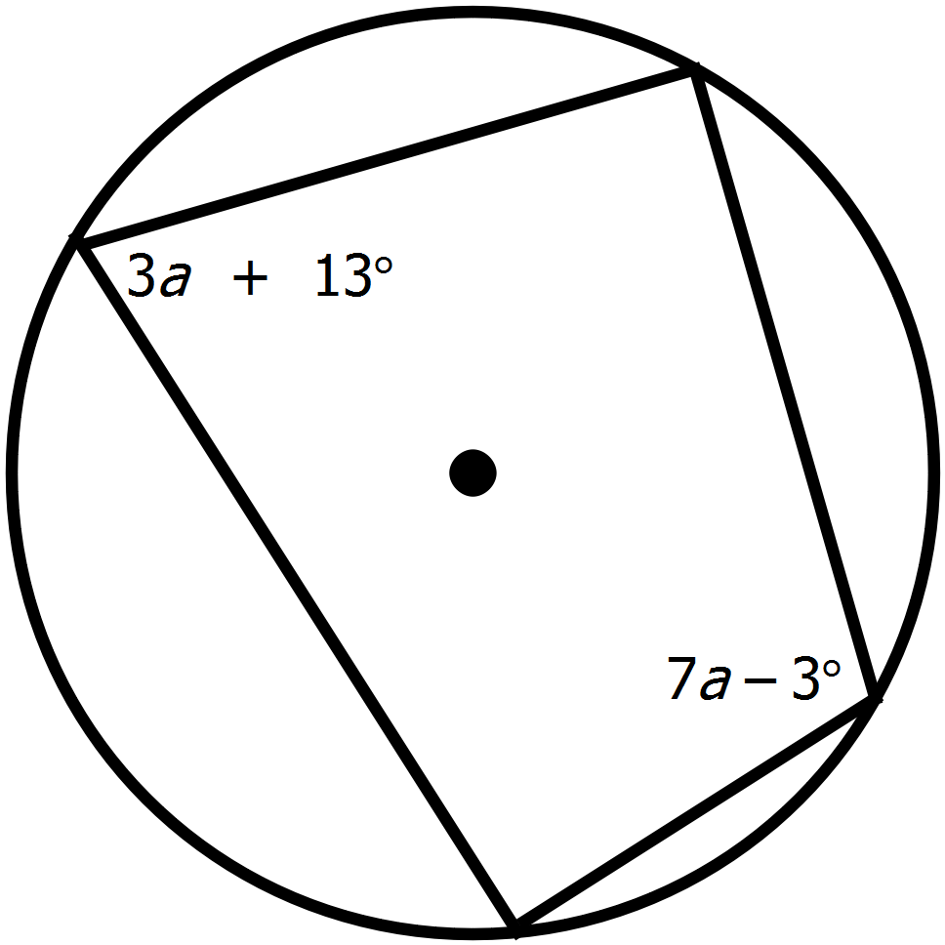
$$3a+13+7a-3=180 (cyclic quad)$$
$$10a=170$$
$$a=17$$

Question 3 6 marks
The position vector of points A, B and C with respect to the origin O are $2i-j$, $-3i-3j$ and $-6i$ respectively.
- Find the position vector of A relative to B. (1 mark)

$$ArB=\vec{OA}-\vec{OB}=\left({2 \atop -1}\right)-\left({-3 \atop -3}\right)=\left({5 \atop 2}\right)$$

- Find the displacement of C relative to B. (1 mark)

$$CrB=\vec{OC}-\vec{OB}=\left({-6 \atop 0}\right)-\left({-3 \atop -3}\right)=\left({-3 \atop 3}\right)$$

- The position vector of the point D relative to C is $-2i+3j$. find the position vector of D relative to O.
(2 marks)



$$DrC=\vec{OD}-\vec{OC}$$
$$\left({-2 \atop 3}\right)=\left({x \atop y}\right)-\left({-6 \atop 0}\right)$$
$$x=-8, y=3$$
$$\vec{OD}=\left({-8 \atop 3}\right)$$

- Find the distance between A and D. (2 marks)

$$\vec{AD}=\left({-8 \atop 3}\right)-\left({2 \atop -1}\right)=\left({-10 \atop 4}\right)$$

$$\left|\vec{AD}\right|=\sqrt{100+16}=\sqrt{116}=2\sqrt{29}$$


Question 4 3 marks
AD and AN are tangents to the circle with centre O.
Prove that Δ ARO and Δ AJO are congruent.
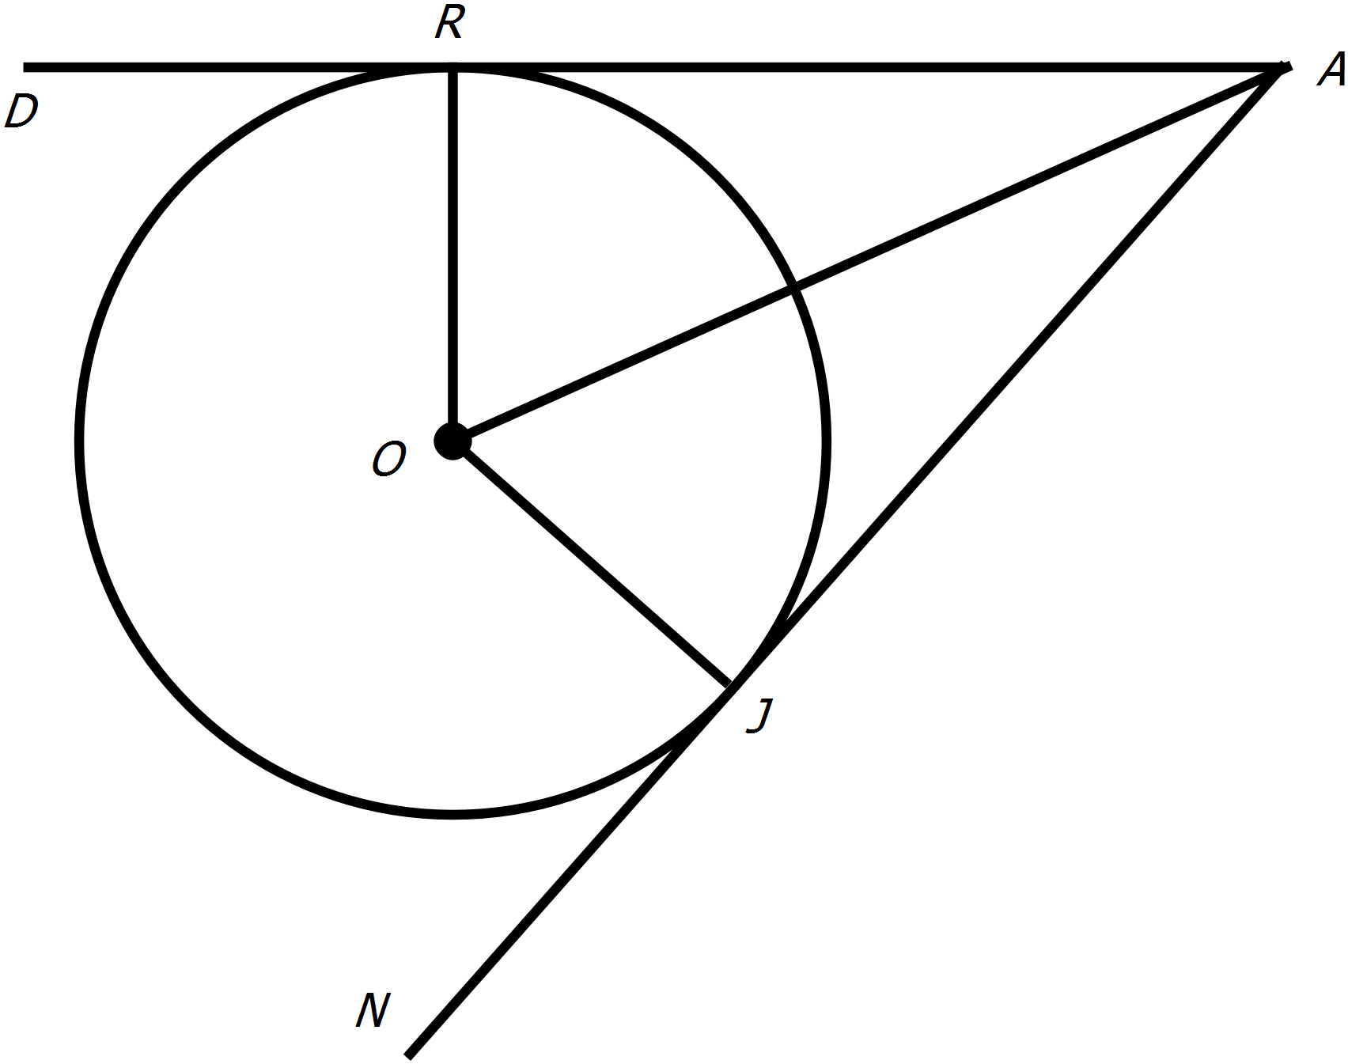




$$AR=AJ (external tangents)$$
$$AO common$$
$$OR=OJ \left(radii\right)$$
$$∆AOR≡∆AOJ (SSS)$$
*correct corresponding angles
*correct congruency test

***Various Answers – mark accordingly***

Question 5 6 marks
Three vertical forces of $300 N$, $400 N$ and $500 N$ are being exerted on the same side of an object. The $300 N$ and $500 N$ forces are exerted either side of the $400 N$ force at angles of $30°$ and $45°$ respectively.
- Find the total acting force. (4 marks)

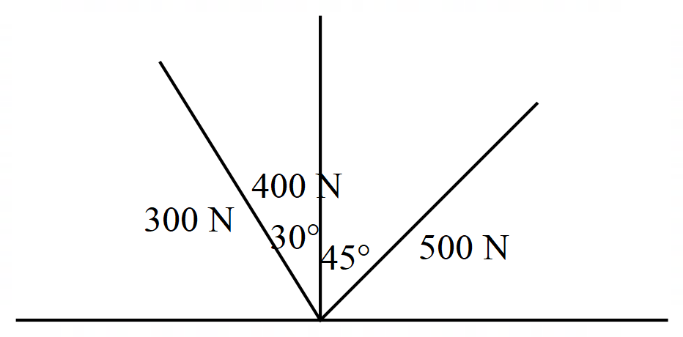

$$a=\left(300 N, 120°\right)=\left({-150 \atop 150\sqrt{3}}\right)$$

$$b=\left(400 N, 90°\right)=\left({0 \atop 400}\right)$$

$$c=\left(500 N, 45°\right)=\left({250\sqrt{2} \atop 250\sqrt{2}}\right)$$

$$total force=a+b+c=\left({-150+250\sqrt{2} \atop 400+150\sqrt{3}+250\sqrt{2}}\right)$$

- Show how to find the bearing of that force. (2 marks)

$$θ=\tan^{-1}\left(\frac{-150+250\sqrt{2}}{150\sqrt{3}+250\sqrt{2}}\right)$$

$$Bearing=90°-θ$$

***Various Answers – mark accordingly***

End of Section One
Additional working space
Question _________

